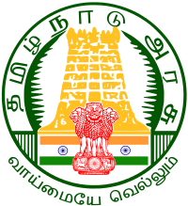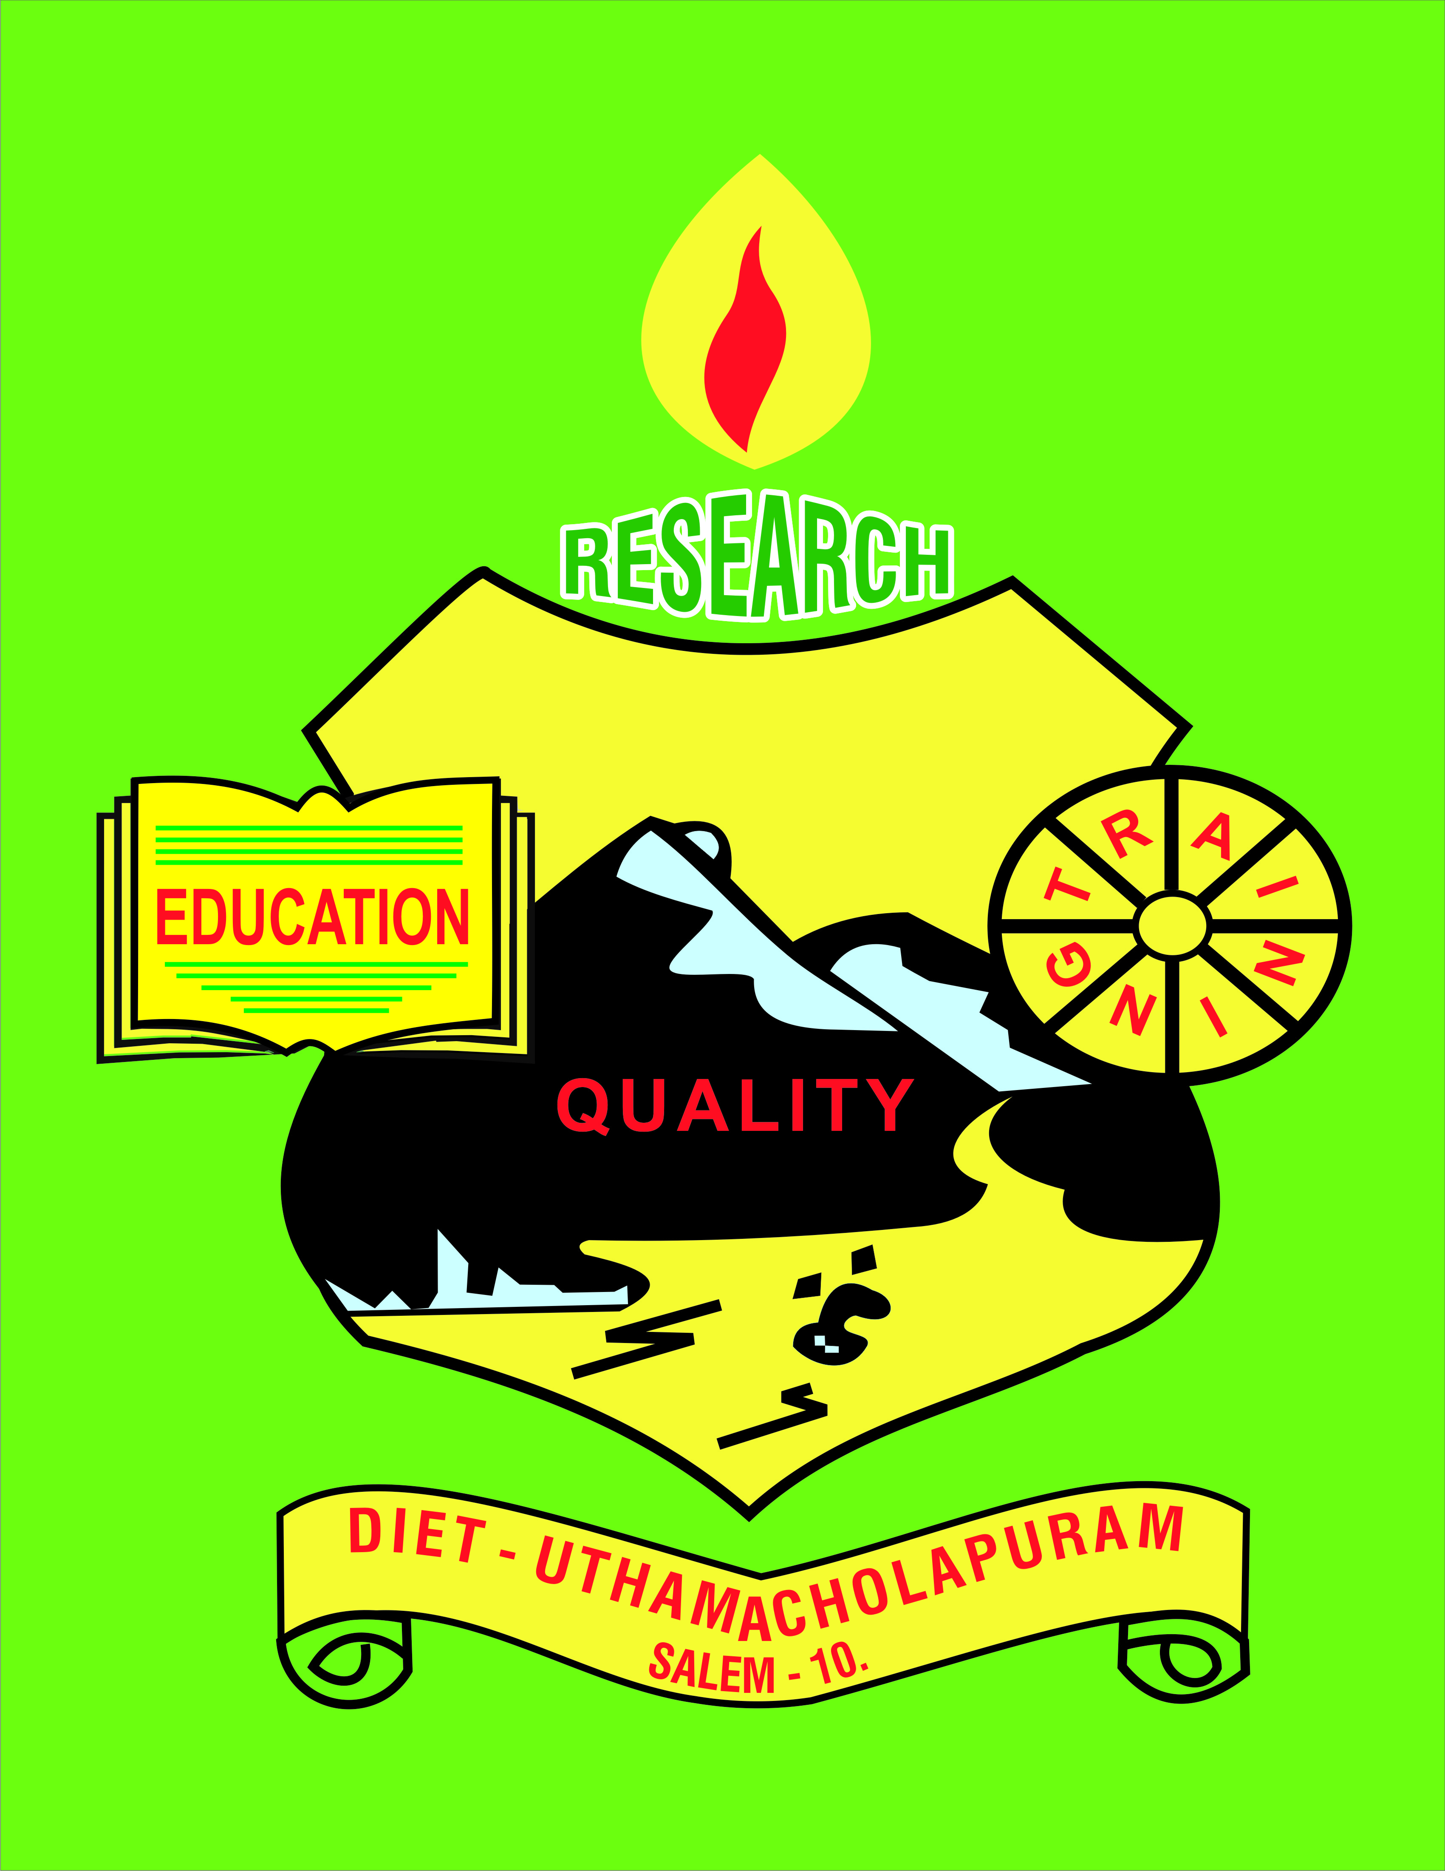

Uthamacholapuram, Salem-636010
August – 2022 PREPARED BY: ET-Branch Vol. No.5 S.No.8

SPECTRUM
ECHO OF DIET SALEM
EE
Ece

Awareness of Educational Rese

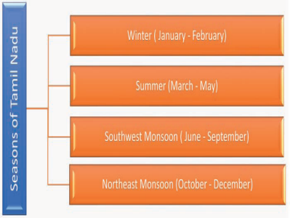
Tamil Nadu – An overview
Introduction Tamil Nadu, bordered by Puducherry, Kerala, Karnataka and Andhra Pradesh is one of the most urbanized states of India. It is home to several natural resources, rare flora and fauna, picturesque hill stations, grand temples of Dravidian architecture, beach destinations and multi-religious pilgrimage sites. It is a land of many educational and research Institution.
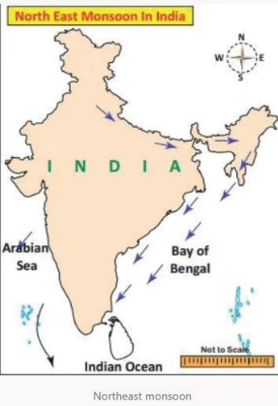
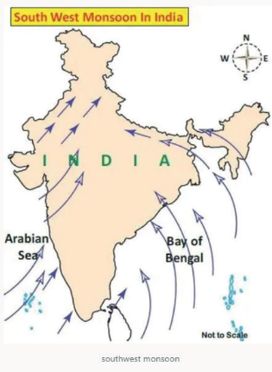
Climate of Tamil Nadu: Predominantly, four seasons can be experienced in Tamil Nadu. They are winter, summer, southwest monsoon, and northeast monsoon. Located in the southern coast of India and close to the equator. Tamil Nadu sees high temperatures throughout the year due to the vertical rays of the sun. Though Tamil Nadu is located in the tropical climate zone, the eastern coast enjoys a tropical sea climate. Both The Indian Ocean and Bay of Bengal have an impact on its coastal climate. Tamil Nadu experiences temperatures ranging from 18◦ C to 43◦ C with an average yearly rainfall of 958.5 mm. The eastern coast is dominated by tropical seas, while the western part of the state is mountainous. This climate prevails in the Nilgiris, Anai Hills and Kodaikanal Hills. Dense forests and high altitudes give the region a pleasant cool climate. The central parts of the state have low altitudes and experience high temperatures and dry climates. Chinnakallar near Valparai is the wettest place in Tamil Nadu and the third wettest place in India.

Soils of Tamil Nadu:
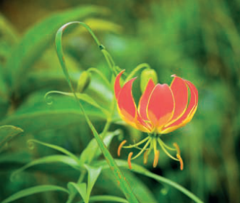
Soil is one of the most important natural resources of Tamil Nadu. We find different types of soil in different parts of the state. These are used for growing a variety of crops. Types of soil are based on their physiography such as a hill, plateaus, coastal lines, rivers, etc. Also, the soil of a place depends on the factors like climate, parent rocks, and vegetative cover of the respective places. The soils in Tamil Nadu are broadly classified into five types 12 May 2022 according to their characteristics. They are 1. alluvial soil; 2. black soil; 3. red soil; 4. laterite soil; and 5. saline soil.
Vegetation
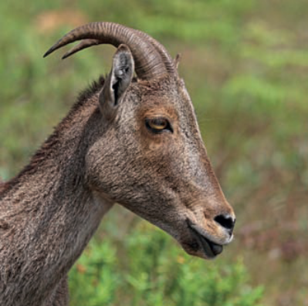
Natural vegetation refers to the forest cover. Landforms, nature of soil, temperature, and rainfall are the major factors that control the distribution of natural vegetation. As per National Forest Policy, 1988, a minimum of one-third of the total geographical area must be under forest cover. The total forest cover of Tamil Nadu is far lower than this. According to the Tamil Nadu State of Forest Report – 2017 assessment, the area under forest in the state is 26,281 sq. km, which constitutes 20.21% of the total area. Tamil Nadu constitutes 2.99% of India’s forest cover. The forest types in the state varies from wet evergreen to scrub forests.
Major Source of Economy for Tamil Nadu, agriculture is the mainstay of life for about half of the working population. Agricultural practices have shown radical improvement since the mid-20th century through multiple cropping, use of stronger and more productive strains of staple crops, and the application of chemical fertilizers. Since the late 1960s the state has been self-sufficient in the production of food grains. The principal crops for domestic consumption are rice, millet, and other cereals, as well as peanuts (groundnuts) and pulses (such as chickpeas); sugarcane, cotton, cashews, and chilies are important cash crops. Many farmers in Tamil Nadu also raise livestock, primarily cows (especially for the dairy industry), poultry, goats, and sheep. Tamil Nadu is one of India’s top fish producers, with most of the yield coming from marine operations; although there are many inland fisheries.
In addition, the state has an active forestry sector, with pulpwood, babul (a type of acacia that yields valuable tannin), firewood, bamboo, and teak among the primary products. Rubber, grown largely in plantations, is important as well.
Educational Institution Tamil Nadu is one of the most literate states in India. Tens of thousands of public and private, primary, middle, and high schools are scattered across the state. In addition, there are numerous arts and science colleges, medical colleges, engineering colleges, polytechnic institutes, and industrial training institutes. Among the most prominent of Tamil Nadu’s universities are the University of Madras and Tamil Nadu Veterinary and Animal Sciences University, both in Chennai; Annamalai University in Chidambaram; Tamil Nadu Agricultural University in Coimbatore; and Madurai Kamaraj University in Madurai. The Dakshina Bharat Hindi Prachar Sabha in Chennai and the Gandhigram Rural University in Gandhigram in southwest-central Tamil Nadu are the two institutes of national importance that are engaged in popularizing the Hindi and Mahatma Gandhi’s concept of rural higher education, respectively. Tamil University near Thanjavur (Tanjore), in the eastern part of the state, focuses on the study of Tamil language, literature, and culture.
Research Institutes
Tamil Nadu is one of the important states of research Institute. The major institutes are CSIR - CECRI, Karaikudi, which has one of the largest electrochemical laboratories in the world, carrying out R&D work in the area of electrochemical Science and Technology. Three extension centres of CECRI are functioning at Chennai, Mandapam, and Tuticorin. The Kodaikanal Solar Observatory runs under IIA – Indian Institute of Astrophysics. It was established in the year 1895 was and it is the May 2022 13 oldest research institute in India. Salim Ali Centre for Ornithology and Natural History (SACON), Anaikatti, Coimbatore is an autonomous organisation established in 1990. National Research Centre for Banana, Tiruchirappalli is also an important institute. Kavalur Observatory is located in Kavalur in the Javadu Hills in Alangayam. Tamil Nadu Science and Technology Centre, Chennai, has the aim to design, develop, and fabricate Science and Technology exhibits, prototype demonstration equipment, and scientific teaching aids for furtherance of science education. Two planetariums are run under this at Chennai and Trichy. Apart from these, there are lot of research institute in Tamil Nadu like the Indian Institute of Food Processing Technology, Thanjavur; ISRO Propulsion Complex, Mahendragiri, Tirunelveli; Dr. A.P.J Abdul Kalam Research Centre, Coimbatore.
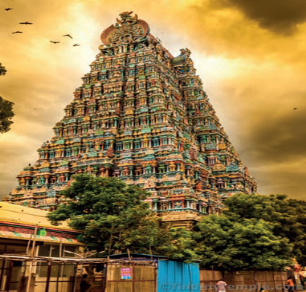
Historical Sites
The 7th- and 8th-century structures at Mamallapuram are famous for their intricately carved temples and rock-cut caves. The best time to visit is during November to February. Madurai, the cultural capital of Tamil Nadu, is one of the oldest continuously inhabited cities of India.
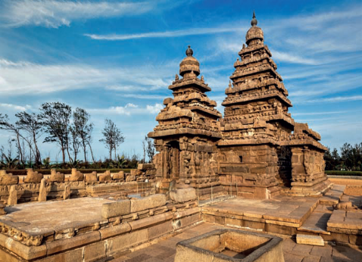
It is known for Meenakshi Amman Temple, Thirumalai Nayakar Mahal and Vaigai Dam. Thiruvannamalai is a town that offers a significant historical place in Tamil Nadu is adorned in its countless temples and ashrams. It is famous for its stunning architecture. Kumbakonam, ‘The Cambridge of India’is known for AdiKumbeshwara Temple.
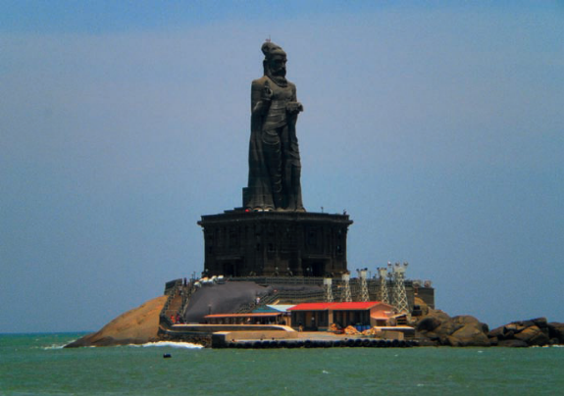
The next important site is Kannyakumari located at the southernmost tip of the Indian peninsula Famous for being the only place in India where you can observe the sunrise and sunset at the same beach, Kanyakumari is a very popular historical place in Tamil Nadu Tanjore, also known as Thanjavur, has a lot of cultural value and is known for its famous Tanjore paintings, antiques, and handicrafts, textiles and saris, its Carnatic music, musical instruments and the temples. Thanjavur is a rich historical place in Tamil Nadu and holds a very important position in the molding of ancient as well as modern south Indian civilization.
Article courtesy by :Mr.Kannabiran,The author is club coordinator of Gallilio Science Club (VP-TN0014). Email: kannatnsfudt@gmail.com

Dr M.Selvam, Principal
- Designed the training programme for Principals on ‘Essential Components in the In-Service trainings from 01.08.2022 to 03.08.2022 at Tabour Retreat, Yercaud, Salem
- Visited the D.El.Ed., Exam Center:
Date | Centre
08.08.2022 | GBHSS, Jarikondalampatty.Salem
11.08.2022 | GBHSS, Jarikondalampatty.Salem
12.08.2022 | GBHSS, Jarikondalampatty.Salem
16.08.2022 | GBHSS, Jarikondalampatty.Salem
17.08.2022 | GBHSS, Jarikondalampatty.Salem
18.08.2022 | GBHSS, Jarikondalampatty.Salem
22.08.2022 | GBHSS, Jarikondalampatty.Salem
23.08.2022 | GBHSS, Jarikondalampatty.Salem
24.08.2022 | GBHSS, Jarikondalampatty.Salem
25.08.2022 | GBHSS, Jarikondalampatty.Salem
29.08.2022 | GBHSS, Jarikondalampatty.Salem

- Participated in the meeting on “Students Safety” which was convened by the District Administrative Office Collector Thiru S.Karmegam, IAS and held at Golden Gates School, Salem on 08.08.2022.
- Participated as Chief Guest in the Annual Day Celebration of Sarabhanka Trust, Omalur on 14.08.2022.
- Celebrated 75th Independence Day at DIET, Salem and launched ‘Math by Abacus’ project on 15.08.2022.
- Assessed the candidates for Dr Radhakrishnan Award -2022 in their School –
Mr P. Arulanantham, HM, GHSS, Pagalpatty, SrSelvin Aqastin Mary, GHS, Vedukathampatty, Mr S.Saravanan, BT Asst, Neelambal Subramaniam School, Salem on 17.08.2022, Mr P.Parameshwaran, GHSS, Pannappatty on 18.08.2022.
- Participated in the Online Workshop on ‘Pedagogical Leadership for Leading Learning in Schools which was organized by NIEPA, New Delhi from 23.08.2022 to 26.08.2022.
- Participated in the approval workshop on management quota in Aided and Self Finance TTI’s at DIET, Chennai on 26.08.2022.
Pre-Service Teacher Education: (PSTE)
Dr P.Govinda Prakash, Senior Lecturer
- 01.08.2022 to 29.08.2022 – Acted as Departmental Officer (DO) for D.El.Ed. Government Examination at GBHSS, Kondalampatti, Salem.
Dr S. Peter Anandh, Lecturer
- Involved in 9thstd Physical Education Learning Outcomes Creation work at DIET.
- Participated in the Online Workshop on ‘Pedagogical Leadership for Leading Learning in schools,which was organized by NIEPA, New Delhi from 23.08.2022 to 26.08.2022.
- Participated in the student approval workshop on management quota in Aided and Self Finance TTI’s at DIET-Chennai on 26.08.2022.
Mrs.S.Selvi, Lecturer
- 01.08.2022 to 16.08.2022 –Attended Communicative English Language Teaching programme at (CLET) RIE, Bengaluru.
- Involved in unit wise 6thstd & 7thstd English lessons Learning Outcome objectives framing work for school teachers at DIET.
Mr R.Ravi, Lecturer
- 01.8.2022 to 05.8.2022 - Participated in five days training programme on Faculty Development Programme organized by SCERT at Tabour Retreat, Yercaud, Salem.
- 11/08/2022 to 17/08/2022-Carried out Mapping of Learning Outcomes for 4thstd, 5thstd & 6thstd Social Science Subject Textbooks at DIET, Salem.
- Involved in Management quota students approval list verification work at DIET ,Salem.
- Participated in the approval workshop on management quota in Aided and Self Finance TTI’s at DIET- Chennai on 26.08.2022.
- Visited Upper Primary CRC at GHS Gundukalur, Nadupatti and Pannapatti at Kadayampatti Block, Salem on 27/08/2022.
In-Service Field Interaction, Innovation and Co-ordination : (IFIC)
Dr K.Ramesh Kumar, Lecturer
- 01.8.2022 to 05.8.2022 - Participated in five-day training programme on Faculty Development Programme organized by SCERT at Tabour Retreat, Yercaud, Salem.
- Participated in the approval workshop on management quota in Aided and Self Finance TTI’s at DIET-Chennai on 26.08.2022.
- 23.8.2022-Visited GHSS Pagalpatti, PUES Tholur and participated in Head Masters meeting for Omalur Block, Salem
- 23.8.2022 to 26.8.2022 NIEPA Training: Attended online workshop on “Pedagogical Leadership for Leading Learning in Schools” organized by NIEPA, New Delhi.
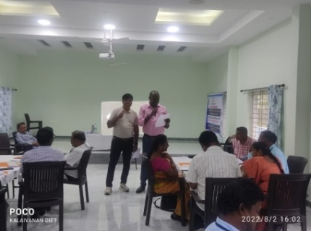
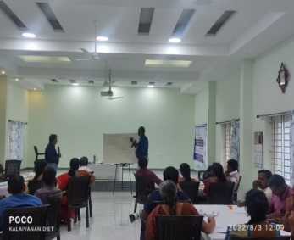
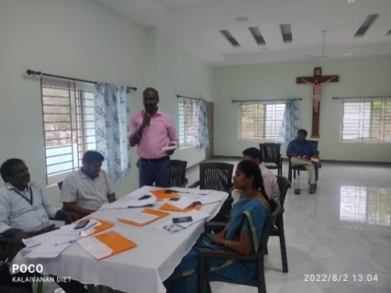
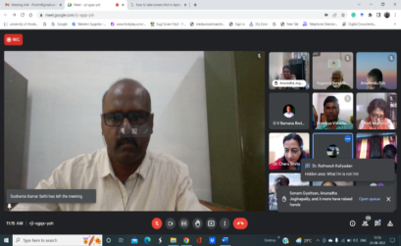
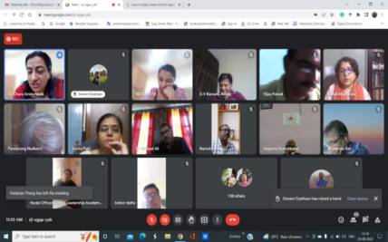

Mrs. M.Mahalakshmi, Lecturer
- 01.8.2022 to 05.8.2022 – Participated 5-Days training programme on Faculty Development Programme organized by SCERT at Tabour Retreat, Yercaud, Salem.
- Organized Mapping of Learning Outcomes in 4th, 5th & 8thstd Mathematics Textbooks at DIET, Salem from 11/08/2022 to 17/08/2022 at DIET, Salem.
- Coordinated ‘Math by Abacus’ project on 15.08.2022.
- Visited Upper Primary CRC at Pethanaikkenpalayam Block, Salem on 27/08/2022.
Educational Technology: (ET)
Dr G.Dhanammal, Senior Lecturer
- Involved in Learning Outcome subject content Mapping with Learning Objectives/ Content for Class 6 & 8 -Social Science subject.
Mrs. M.Jayamani, Lecturer
- Attended the 5 day’s Professional Skill Development Training- Essential things (Phase II) at Tabor Retreat Centre, Yercaud, Salem conducted by SCERT, Chennai from 01/08/2022 to 05/08/2022.
- Mapping of Learning Outcomes for class 4 to 8 Tamil Textbooks work was seen at DIET, Salem from 11/08/2022 to 17/08/2022.
- Visited Upper Primary CRC at Edapadi Block, Salem on 27/08/2022.

Dr V. Suganya, Lecturer
- Attended the 5 day’s Professional Skill Development Training- Essential things (Phase II) at Tabor Retreat Centre, Yercaud, Salem conducted by SCERT, Chennai from 01/08/2022 to 05/08/2022.
- Carried out Mapping of Learning Outcomes in standard 6 & 8 Science Textbooks at DIET, Salem from 11/08/2022 to 17/08/2022.
- Involved in Management (CSI TTI, St Joseph TTI & Ezhil TTI) quota student’s approval list verification work at DIET, Salem.
- Visited Upper Primary CRC at GHS Ayothiyapattinam Block, Salem on 27/08/2022.

Curriculum, Material Development and Evaluation: (CMDE)
Dr R.Nagalakshmi, Senior Lecturer
01.08.2022 | Attended Principal meeting regarding Personality Development Programme for Higher Secondary Students.
02.08.2022  &  04.08.2022 | Prepared Learning Outcome content for Science subject of Class 5-Term I- matching with learning objectives at DIET.
05.08.2022 | Visited and Observed the Ennum Ezhuthum classroom activities at Valapady Block Schools.
08.08.2022  &  18.08.2022 | Prepared Learning Outcome content for Science subject class 5-Term I- matching with learning objectives at DIET.
22.08.2022 | Attended Principal meeting regarding Personality Development Programme for Higher Secondary Students at DIET,Salem.
23.08.2022 to  26.08.2022 | Attended NCSL-NIEPA Online workshop on Pedagogical Leadership at DIET, Salem.
27.08.2022 | Visited CRC center to GBHSS, Valapady.
29.08.2022  & 30.08.2022 | Coordinated Textile Dress Designing MCQ preparation for class 12 at DIET,Salem.

Dr B.Ananthi, Lecturer
- Attended the 5 day’s Professional Skill Development Training- Essential Things (Phase II) at Tabor Retreat Centre, Yercaud, Salem conducted by SCERT, Chennai from 01/08/2022 to 05/08/2022.
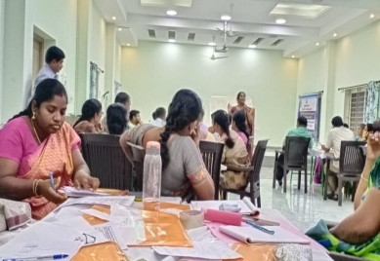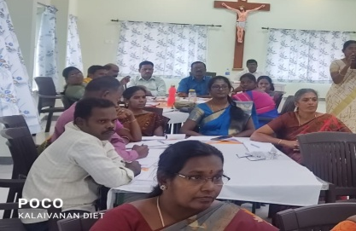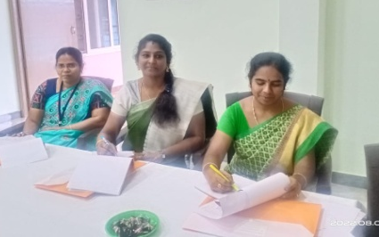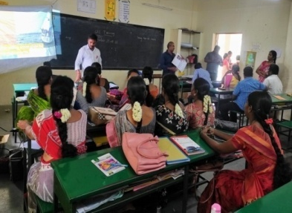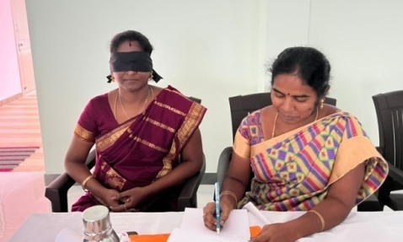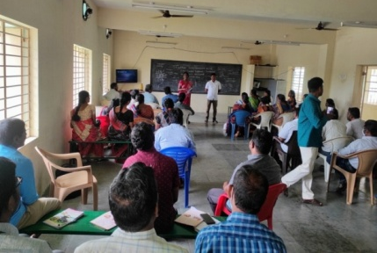
- Mapping of Learning Outcomes in standards 4, 5 and 8 English Textbooks at DIET, Salem from 11/08/2022 to 17/08/2022.
- Visited Upper Primary CRC at GHS, Katchupalli, Konganapuram Block, Salem on 27/08/2022.
District Resource Unit :( DRU)
Dr T. Prabhakaran, Senior Lecturer
- Visited and Observed Ennum Ezhuthum -School Classroom activities at Panamarathupatti Block.
- Visited Upper Primary CRC at Panamarathupatti Block, Salem on 27/08/2022.
Dr P.So.Kesavan-Lecturer
- Prepared the Learning Outcomes Mapped with Learning Objectives/Content for Class 5- First Term –Science at DIET.
- Participated and Discussed in the faculty meeting regarding the Training “Personality Development Training” for students
- Prepared the Learning Outcomes Mapped with Learning Objectives/Content for Class 7 -First Term –Science at DIET.
- Coordinated and Corrected Class 11- Textile and Dress Designing – Tamil and English version MCQs for Units 1, 2 & 3 at DIET.
- Visited CRC : Teacher Professional Development Training for Class 6 to 10 Teachers at GHSS, Veerapandi on 27.08.2022
CRC VISIT, GHSS , VEERAPANDI
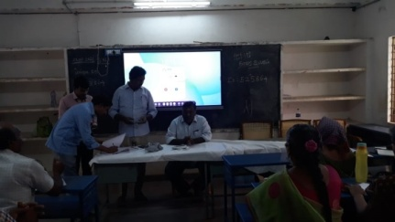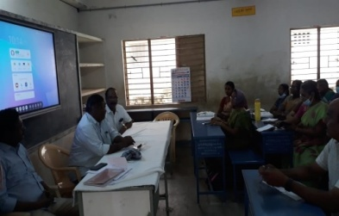
Planning and Management: (P&M)
Dr K.Kannaki, Senior Lecturer
- 01.08.2022 to 29.08.2022 – Acted as Route Officer at GBHSS, Kondalampatti in D.El.Ed., Government Examination Center.
Mr. B.Uthaya Kumar, Lecturer
- Visited ITK Centre at Sankagiri Block.
- Acted as Resource Person in “Career Guidance” online workshop for Salem District HM’s.
- Prepared Learning Outcomes Mapped with Learning Objectives/Content for Classes 6 & 7 -First Term – Biological Science at DIET.
- Visited CRC: Teacher Professional Development Training for Class 6 to 10 Teachers at Sankagiri Block on 27.08.2022.

Work Experience Branch:(WE)
Dr S.V.Vijayalakmi Shankar, Senior Lecturer
01&  02.8.2022 | Prepared contents Relating of LO with concepts for class 5 science subject at DIET.
04.8.2022 | Prepared contents Relating of LO with concepts for class 5 science subject at DIET.
11.8.2022 | Attended Principal meeting and Learned about digital Tools at DIET.
12.8.2022 | Preparation of “Aasan Avai” Document work was seen.
14.8.2022 | Conducted online meeting through Google Meet on -AASAN AVAI -38thSpecial programme-DIET & Rotary MoU -Resource Person : Mrs. Senthilvadiyu &  Mrs Punitham, SGT, Tharamangalam, Salem Topic: “How to prepare low cost and no cost TLM”.
16.8.2022 | Preparation of Immersive Technology module -Bamboozle documentation work was done.
17.8.2022 | Preparation of Immersive Technology module –Bamboozle documentation work was seen.  Attended Online meeting of Mecheri BEO’s to discussed about EE training programme.
18.8.2022 | Attended Online meeting for Tharamngalam block teachers to discussed about EE training programme.
19.8.2022 | Preparation of Immersive Technology module -Bamboozle documentation work was seen.
21.8.2022 | Conducted online meeting through Google Meet on-AASAN AVAI -39th Special programme-DIET & Rotary MoU -Resource Person : Mrs.Devipriya, Psychologist, Helix School, Salem .Topic: Visual Imagery Strategy
22.8.2022 | Attended Principal meeting to discuss about collector meeting at Collectorate, Salem.
23.8.2022 | Preparation of Immersive Technology module -Bamboozle documentation work was seen.
24.8.2022 -26.08.22 | Preparation of Immersive Technology module -Scratch document work was seen.
27.8.2022 | Visited CRC-GGHSS, Tharamangalam Block.
28.8.2022 | Conducted online meeting through Google Meet onGoogle Meet-AASAN AVAI -40thSpecial programme - DIET & Rotary MoU -Resource Person : Mrs.Kala, Mrs.Megala & Mr.Elangovan, SGT, Mecheri block Topic: Strategy to Handle EEM classroom.
29.8.2022 | Preparation of Immersive Technology module –Scratch programme documentation work was seen.
30.8.2022 | Action Research related preparation work was seen.

Mr C.Anbarasan, Lecturer
- Attended the 5 day’s Professional Skill Development Training- Essential things (Phase II) at Tabor Retreat Centre, Yercaud, Salem conducted by SCERT, Chennai from 01/08/2022 to 05/08/2022.
- Visited ITK Centre at Kolathur Block.
- Acted as Resource Person in “Career Guidance” online workshop for Salem District HM’s.
- Prepared Learning Outcomes Mapped with Learning Objectives/Content for Class 4-First Term –EVS subject.
- Visited CRC: Teacher Professional Development Training for Class 6 to 10 Teachers at Kolathur Block on 27.08.2022.
- Involved in 12thstd Chemistry Video Mapping Work at DIET,Salem.
Dr K.Kalaivanan, Lecturer
- Attended 5-Day’s Professional Skill Development Training- Essential Things (Phase II) at Tabor Retreat Centre, Yercaud, Salem conducted by SCERT, Chennai from 01/08/2022 to 05/08/2022.
- Visited CRC Teacher Professional Development Training for Class 6thto10thTeachers at Gangavalli Block on 27.08.2022.
Mr. K.Satchidanandam,Librarian
- Labeling and Barcoding of library Books was done.
- Library daily transaction was seen.
- Need Based library referral services to DIET faculty members.
- Library Books- Data Entered in the library software.
- Library books provided to School teachers for mapping workshop.
- Website updating was made.

Chief Editor : Dr M.SELVAM, PRINCIPAL
UTHAMACHOLAPURAM,
SALEM-636010
Associate Editors : G.DHANAMMAL(SL),
Mrs .V. Suganya (L),
Editor : Mrs. S.Selvi (L)
Phone : 7373003460
Website : www.dietsalem.com
E-Mail Id : dietslm@gmail.com
This Newsletter is Prepared and Published by ET Branch



